Princess Mako weds after drawn-out engagement drama
The Japan Times

New life with Kei Komuro in New York awaits following tumultuous four-year saga
- BY TOMOHIRO OSAKI
- Oct 26, 2021
Princess Mako formally tied the knot with her college sweetheart Kei Komuro on Tuesday, relinquishing her royal status and bringing closure to a four-year engagement saga marred by scandal and public backlash.
In a much-anticipated, nationally televised news conference Tuesday afternoon, the 30-year-old newlyweds made a joint appearance at a Tokyo hotel to announce their marriage. Having officially registered the nuptials with a municipality earlier that day, Mako, a niece of Emperor Naruhito, became Mako Komuro, leaving the imperial family to reportedly start her new life with him in New York.
“Kei is a precious being for me. Marriage is a necessary choice we had to make,” Mako, wearing a pale green dress and pearls, told the news conference, where she and her husband took turns reading from a script.
“I love Mako,” said Komuro, clad in a dark suit. “I want to spend my life — which I can only live once — in the company of someone I love.”
The two began their address with slightly nervous expressions, but as the minutes passed, they gradually relaxed into smiles, offering a glimpse of the reassurance each has found in the other’s company.
Nonetheless, the theme of mental health was revisited throughout their 10-minute speech, and they expressed thinly veiled dismay at the onslaught of verbal abuse that has been directed at their marriage over the past four years — including personal attacks on Komuro and his family, particularly on social media. Earlier this month, the Imperial Household Agency revealed that the princess had been diagnosed with complex post-traumatic stress disorder over what she felt to be the widespread vilification of her partner, his family and herself.
What started as the epitome of a royal fairy tale — a princess falling in love with a university classmate — quickly went awry when reports emerged in late 2017 that Komuro’s mother was embroiled in a financial dispute with her former fiance, who claimed she owed him over ¥4 million, which included money spent on the young Komuro’s education.
“We have been horrified, scared and saddened by the fact that false information has been taken as fact and that unfounded stories have spread,” Mako told the news conference.
Separately, in her written answers to the media, she said her biggest fear going forward is the “possibility that defamation against me and my family, as well as Kei and his family, may continue.” She also wrote that her mental condition is “far from good,” but that she has been just about able to persevere thanks to the support of those around her.
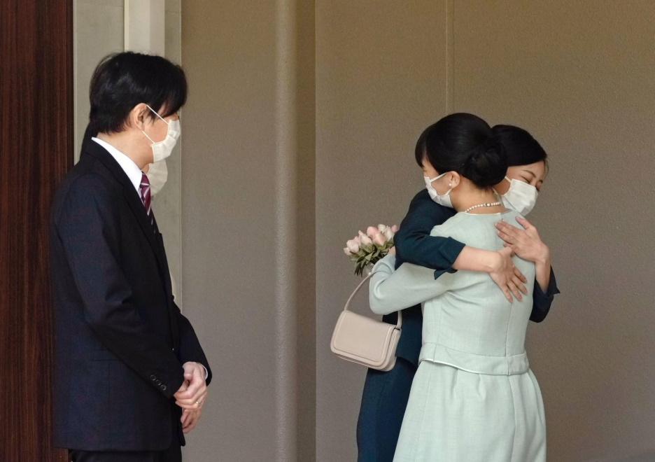
Princess Mako and her sister, Princess Kako, hug each other as she leaves her family’s residence in Tokyo on Tuesday morning on the day of her marriage to Kei Komuro. | KYODO

Komuro also said during his appearance that misguided speculation and persistent attacks have mentally and physically exhausted his mother, forcing her to quit her job and continue to “live in fear of her life.”
Their concerns over the attacks were evident in the way the news conference was conducted: While it was originally arranged for the couple to make a prepared statement and then proceed to a question-and-answer session, the Imperial Household Agency announced at the last minute that the two wouldn’t take any questions after all. Their answers to the questions, the agency said, would be provided in writing instead.
According to the agency, some of the questions pre-submitted to the agency included statements that “risked making false information sound as if it were facts.” Mako, the agency said, was “extremely shocked” by these questions and also “extremely frightened” at the thought of having to hear them publicly read aloud and then go about answering them there and then.
In her written answers to the media Tuesday, Mako singled out particular questions asked by the Japan Magazine Association as being inappropriate. The organization dredged up accusations that Komuro’s mother was illicitly receiving a pension for a bereaved family from the government, and also that he somehow used his status as someone betrothed to a Japanese princess to make his way into Fordham University’s law school in New York. In response, Komuro denied those allegations.
“I believe there are many people out there who are suffering and having difficulty living while protecting their minds,” the former princess told the news conference in a closing remark. “I truly wish our society will become one where more people are able to receive support and help from those around them, and take good care of their minds.”
On Monday night, with the news conference having largely been seen as the last opportunity for Komuro to explain directly to the public about the money issue, the abrupt ditching of a full Q&A session had hit a raw nerve on the internet: An article on the reformatted news conference that was featured on the Japanese edition of Yahoo News was inundated with so many comments deemed problematic that its comments section was hidden — a rare step taken as part of the online portal’s new measures against online slander.
The allegations leveled at Komuro’s mother caused some to question the repute of the family that the princess was about to be associated with, prompting tabloid media to relentlessly pursue the scandal.
The path taken by the newlyweds has been like nothing seen before. All traditional rituals and celebrations typical of a female royal’s marriage to a member of the general public were canceled in the lead-up to Tuesday, reflecting mixed public sentiment toward the marriage. Crown Prince Akishino, the father of Mako, at one point expressed his view that many Japanese people remain unconvinced by their union.
With the controversy having dragged on and never being fully dealt with in the minds of many Japanese people, Mako declined to receive a lump sum payment of up to around ¥150 million that is usually granted to female members of the imperial family upon their departure from the household.
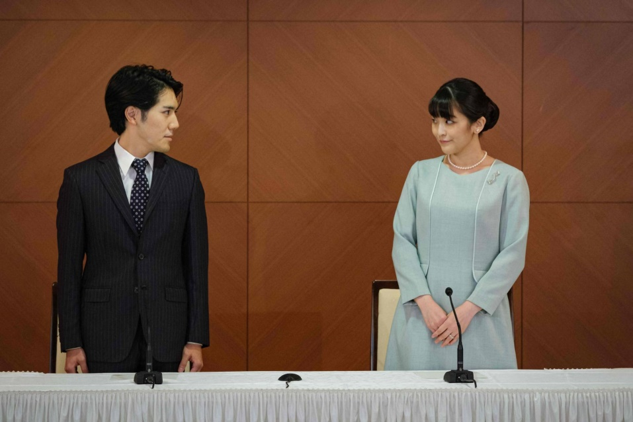
Mako Komuro (right), the elder daughter of Crown Prince Akishino and Princess Kiko, and her husband, Kei Komuro, who she originally met while at university, pose during a news conference to announce their marriage, at the Grand Arc Hotel in Tokyo on Tuesday. | POOL / VIA AFP-JIJI

For both Mako and Komuro, it has been a difficult and tumultuous four years.
When he first appeared alongside Mako to jointly announce their engagement, in 2017, Komuro made a generally favorable impression on the nation with his bright smile and debonair demeanor. At that point, the atmosphere surrounding the couple was that of an all-out celebration, with the public touched by the charming way Mako likened her boyfriend’s radiant smile to the sun and how he, in turn, likened her serenity to the moon.
The two met while studying together at International Christian University in Tokyo’s Mitaka city.
But amid the frenzy over his family’s money troubles, their marriage was abruptly postponed in February 2018.
In summer that year, Komuro, an aspiring lawyer, left Japan for New York to study law there for three years. What was taken to be his silence on the money scandal subsequently triggered a rebuke from Crown Prince Akishino, who called on the Komuro family to offer a fuller explanation of the matter and even voiced his doubts that the Japanese public was in a mood to celebrate the marriage.
Nonetheless, it seems Mako’s resolve to marry Komuro remained unwavering throughout. In November last year, she released a statement reiterating her determination to go ahead with the marriage.
“I realize that there are those who hold negative views about this marriage for various reasons,” she wrote. “But we view ourselves as precious partners who can depend on each other both in our happy and unhappy times.”
When Komuro released a 24-page document in April this year detailing his views on the financial dispute, Mako defended him with her own statement asking that his explanations be “understood” by the public.
All eyes are now on what their life together in New York will look like.
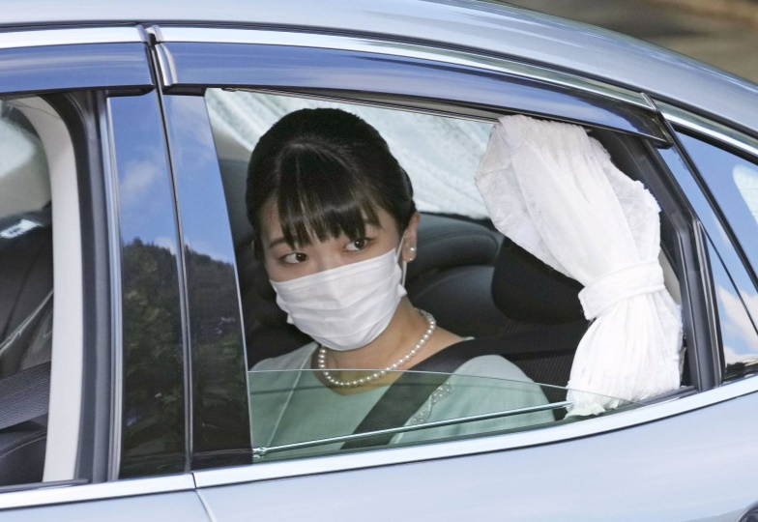
Princess Mako leaves her family’s residence at the Akasaka Estate in Tokyo on Tuesday morning. | KYODO

Earlier this year, Komuro graduated with a Juris Doctor degree from Fordham University’s law school. Having taken the New York state bar exam in July, he has already started working at a local law firm. Depending on the results of the exam, which are expected to be announced around mid-December, he may be officially promoted to an attorney position.
Their expected move to the U.S. has drawn comparisons to Britain’s Prince Harry and his wife, Meghan Markle, but Mako said she doesn’t “have any particular thoughts” about being compared to Markle, nor does she intend to give any interviews to the media about her future personal life.
“What I would like is just to lead a peaceful life in my new environment.”

