Bagehot
The four faces of Boris Johnson
Player, gambler, Machiavelli or piglet?
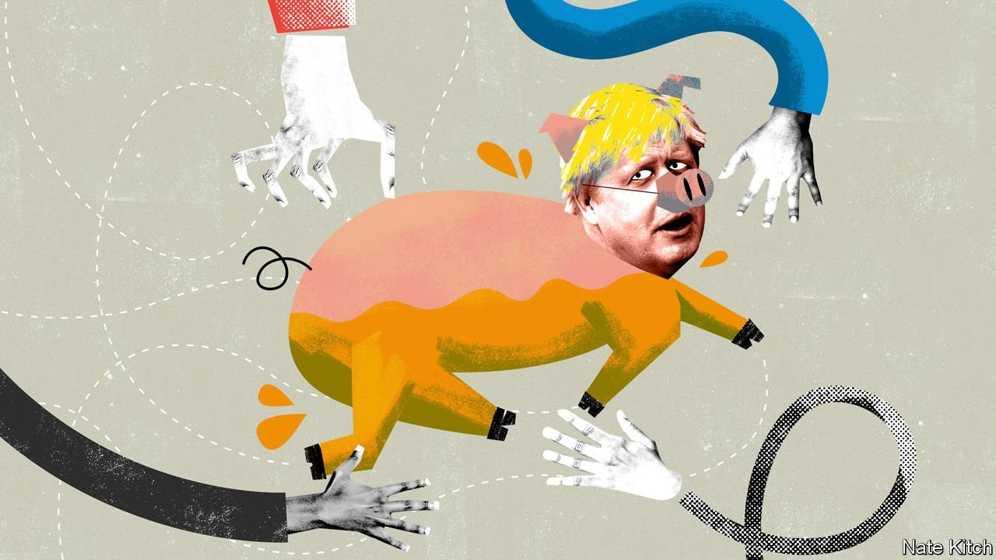

Boris johnson at last has his rendezvous with the great British public. Mr Johnson was installed in Downing Street in July by an electorate of just 160,000 Conservative Party members. Now he has to prove himself before a larger and more critical audience. This audience will be bombarded with promises and propaganda over the next six weeks. But Mr Johnson’s unusual probationary period in Downing Street gives them a chance to judge him by his record. What have we learned about the prime minister’s political character and leadership style so far?

One thing is certain: he has defied expectations, both positive and negative. Mr Johnson was frequently presented as a jovial figure—a clown or Bertie Wooster-style buffoon. He liked to make people laugh. He laced his language with eccentric phrases. He created an impression of affable disorganisation. But though he can still make people smile, he is much more focused and disciplined than anyone expected. The iron has entered his soul.

A more appropriate image than a clown is that of a rugby captain. A fan of the game, who played for his college at Oxford, the stockily built Mr Johnson has brought many of the techniques of the sport to the political field. He has demonstrated a single-mindedness: everything he does is about getting the ball over the line. He has shown no hesitation about altering the composition of his team according to his changing game plan, kicking 21 Tories out of the party when they defied him and then re-admitting ten of them when the general election knocked. And he has kept his eye on the clock, using timetables and deadlines to keep the game moving—though he must regret installing “Brexit clocks” in both Downing Street and Conservative Party headquarters set to hit zero on October 31st, a deadline that he has now missed.
More recently Mr Johnson has applied the same drive that he applied to Brexit to securing a general election, fixating on a particular date (December 12th) and threatening to go on strike if the opposition parties didn’t bend to his will. This has produced some criticism about moving the goal posts. Philip Hammond, a former chancellor, accused Mr Johnson of “blocking Brexit” in order to pursue a wider objective of shifting the Tory party to the right. That is not quite right. Mr Johnson calculates that he can’t get his Brexit deal through the current House of Commons without endless amendments and delays. He also realises that his deal is only the opening salvo in prolonged negotiations which will shape what sort of Brexit Britain ends up with.

A second image is that of a greased piglet. This comes courtesy of David Cameron, Mr Johnson’s junior at Eton by two years and senior in Downing Street by nine, who recently told an audience in Yorkshire that “the thing about the greased piglet is that he manages to slip through other people’s hands where mere mortals fail.” Mr Johnson has broken an ever-lengthening list of pledges. He pledged to deliver Brexit “do or die” by October 31st, only to discover that he couldn’t. He promised to be “dead in a ditch” rather than send a letter asking for an extension, only to send exactly such a letter. He so alienated his colleagues that he reduced his majority from plus one to minus 45. But the grease works. Mr Johnson either wriggles through loopholes (for example, by refusing to sign said letter) or else shifts the blame expertly to anyone but himself. “It’s Parliament’s fault, it’s the opposition’s fault, it’s the Benn act, it’s Germany, it’s Ireland,” proclaimed an exasperated Sir Keir Starmer, Labour’s Brexit spokesman, trying to define the prime minister’s slippery style.
The third image is that of Machiavelli. Mr Johnson employs all the great Florentine’s tactics. He treats his opponents as enemies of the people. He throws his allies under the bus as soon as they cease to be useful (the decision to sacrifice the Tories’ long-standing ally, the Democratic Unionist Party, in order to solve the problem on the Irish border will go down in the annals of realpolitik). He uses his clown’s mask to great effect to conceal his Machiavellian side, saying toxic things one moment and telling a good joke the next. He breaks the rules of politics in ways that shock old hands such as Sir John Major. He persuaded the queen to prorogue Parliament on spurious grounds and was subsequently slapped down by the Supreme Court. And he employs a hatchet man in the form of Dominic Cummings, his chief adviser, who happily takes the blame for some of Downing Street’s more extreme moves. Mr Cummings’s enthusiasm for using privileged briefings in order to turn the press corps into an amplifier has aroused the ire of one of Fleet Street’s most experienced journalists, Peter Oborne, who wrote a furious article arguing that Downing Street is filling the press with lies, smears and character assassinations. The Downing Street machine continues with business as usual while Mr Oborne has given up his political column in the Daily Mail.

Double or nothing
The last image is that of the gambler. Mr Johnson has spent his career making lucky bets—lucky for him, that is, not the rest of the country. He made his career as a journalist betting that the public wanted bureaucracy-bashing stories from Brussels, rather than the usual dutiful fare. He became prime minister by betting on Leave. Now he is making yet another gamble, which may free him from today’s imprisonment by Parliament but could easily install Labour’s socialist leader, Jeremy Corbyn, in Downing Street. The Tories go into this election facing big losses in Scotland and the Remain-voting south of England. They have to overcome powerful tribal ties to Labour in Wales, the Midlands and the north in order to make up for these losses. Moreover, Labour is a much more impressive electoral machine than most Tories seem to think. Mr Corbyn already has a new spring in his step and the party is bombarding the internet with clever ads. Even the luckiest of gamblers sometimes loses—and even the greasiest of piglets sometimes ends up in the abattoir.

